Url:- <https://www.makemytrip.com/>

Scenario:-Select the user given date from the date picker

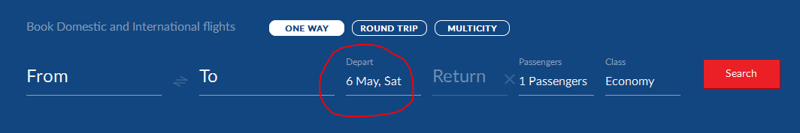

Here user does not have tendency to click on the date widget, but the user needs to click on the date. How to do this.

This is simple by doing the following steps:-

**1.Launch the browser**

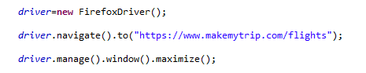

**2.Now click on the date field**



**3.Define a date for which you need to Select**

**Ex:-** **12/10/2017**

**4.Create a user defined function that which accepts the user defined date**

**5.Declare a date format and parse the user defined date to the format “dd/MM/yyyy”**

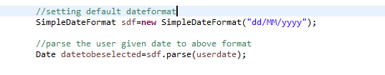

**6.Get the date from the calendar widget available on the Application**

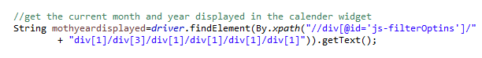

**7.Now get the Month,Year,Day from the user given date**

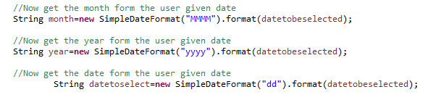

**8.** **Now concat the month and year and convert it to upper case as in widget we are getting in capitals**

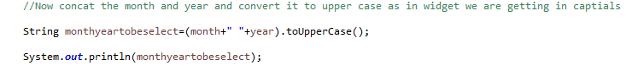

9 Now compare the user given date is equal to calendar widget date

